**Synopsis of**

**ONLINE SHOE SHOP**

###### BY

###### RIYA BHARTI

###### RADHA RAJ

###### ABDUL RAHAMAN

###### NETRAVATI

**INTRODUCTION**

This project is a web based shopping system for an existing shop. The project goal is to deliver the online shopping website using java.Online shopping is the process whereby consumers directly buy goods or services from a seller in real-time, without an a service, over the internet. It is a form of electronic commerce. This project is an attempt to provide the advantages of online shopping to customers of a real shop.It helps buying the shoes in the shop anywhere through internet by using this. Thus the customer will get the service of online shopping and home delivery.

# **OBJECTIVE**

The objective of the project is to make an website to purchase items in an existing shop. In order to build such an application complete web support need to be provided. A complete and efficient web application which can provide the online shopping experience is the basic objective of the project.The web application can be implemented in the website.

### BACKGROUND

## The central concept of the application is to allow the customer to shop virtually using the internet and allow customers to buy the shoes from the shop. The information pertaining to the products are stores on database.

### HARDWARE AND SOFTWARE REQUIREMENTS

##### Hardware Requirements

|  |  |
| --- | --- |
| Hardware Tools | Minimum Requirment |
| Processor | i5 or Above |
| Hard disk | 20 GB |
| RAM | 4 GB |
| Monitor | 17” colored |
| Mouse | Optical |
| Keyboard | 122 keys |

##### Software Requirements

|  |  |
| --- | --- |
| Software Tools | Minimum Requirement |
| Platform | Windows |
| Operating System | Windows 7 or above |
| Technology | Java Enterprise Edition(Java EE 7) |
| Database | MySQL Server |
| Web Server | Apache Tomcat 8.0.3.0 |
| Scripting Language | JSP(Java Server Pages),Servlets |
| IDE | Netbeans 8.2 |
| Database JDBC Driver | MySql Jconnector |
| Web Browser | Any of Chrome,Mozilla ,etc |

**DFD:**

**Context level:**

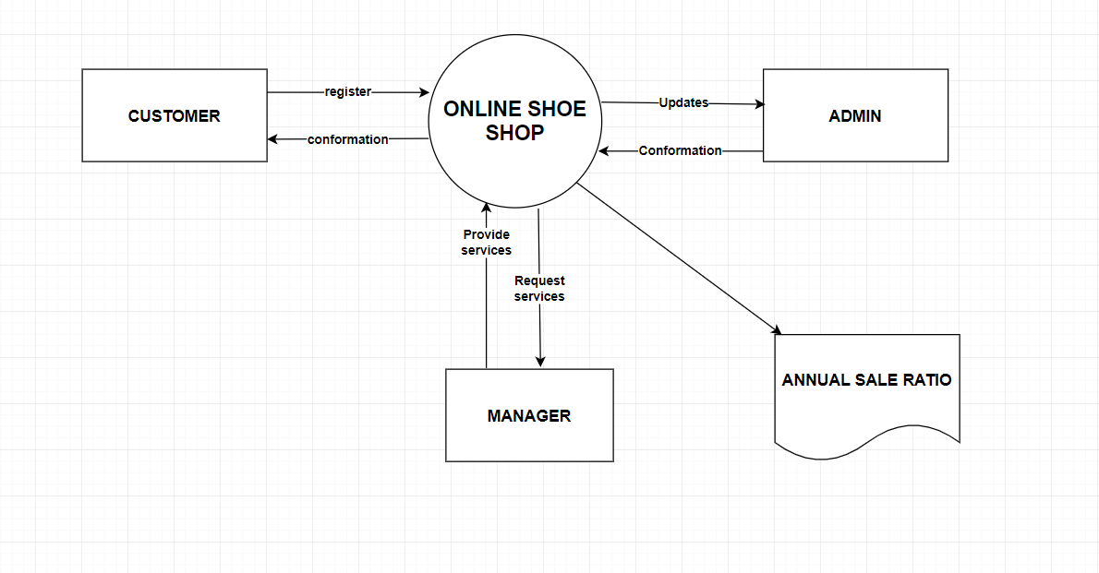

**DFD Level 1:**

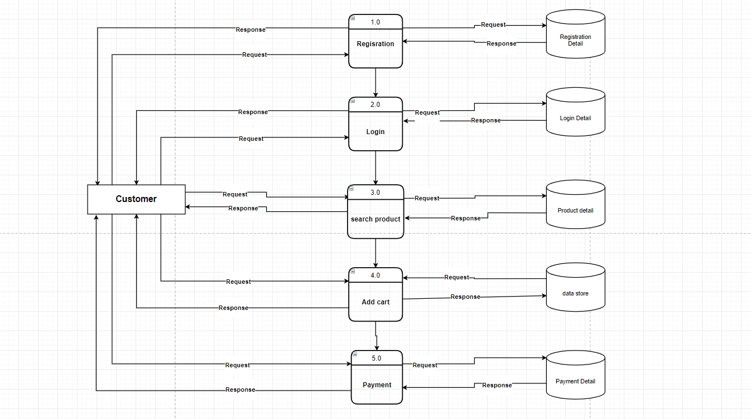

### ER-DIAGRAM

### 

### FORM LAYOUTS

**Homepage:**

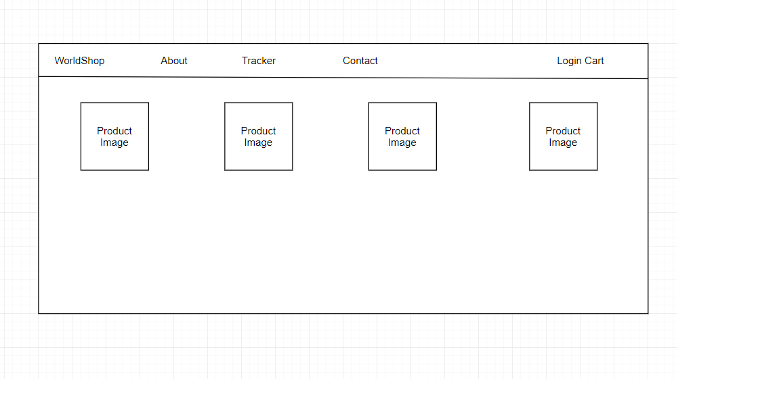

**Login page:**

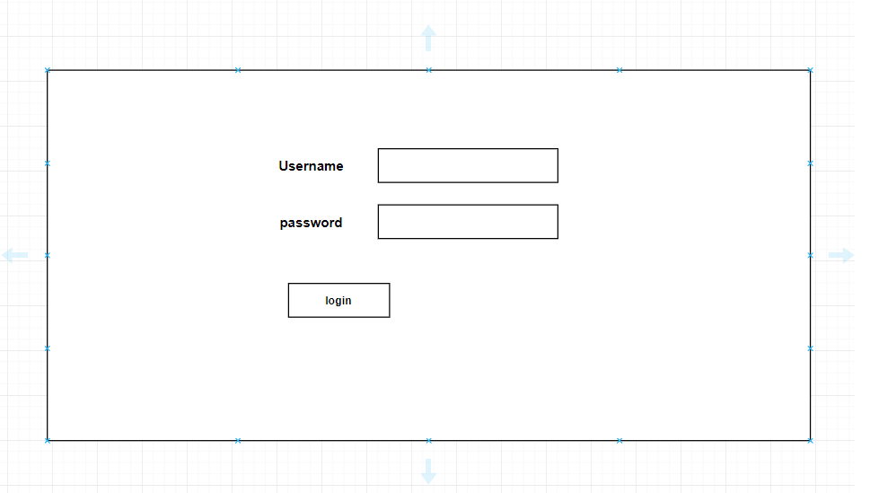

**About page:**

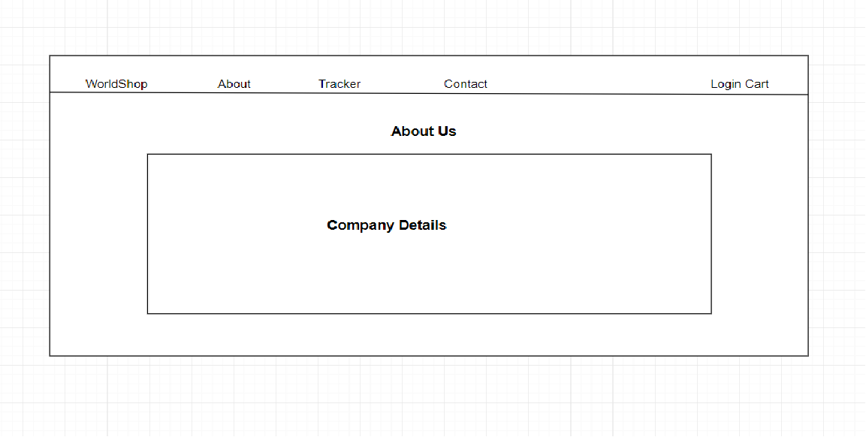

**Contact page:** 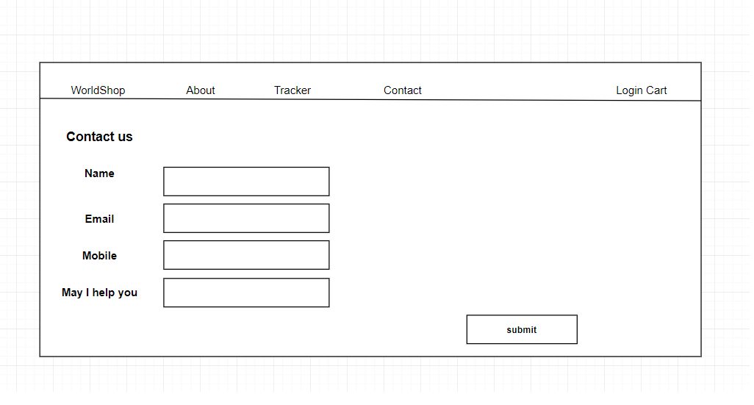

### DATABASE SCHEMA

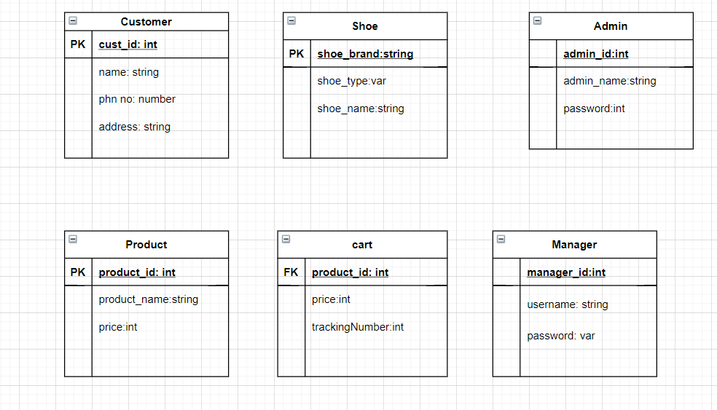

**CONCLUSION**

Our project is only a humble venture to satisfy the needs to manage their project work. Several user friendly coding have also adopted. This package shall prove to be a powerful in satisfying all the requirements of the customer. The objective of software planning is to provide a frame work that enables the manager to make reasonable estimates made within a limited time frame at the beginning of the software project and should be updated regularly as the project progresses.

### REFERENCES AND BIBLIOGRAPHY

* <https://www.draw.io>
* <http://www.jdbc-tutorial.com/>
* <http://wwwtutorialspoint.com/mysql/>
* <http://www.JSP.net/>